**8TH BASKETBALL**

Champions…LEXINGTON…

Second Place..BROOKHURST

Third Place…..ORANGEVIEW

Consolation…..BALL

**7TH BASKETBALL**

Champions…LEXINGTON…

Second Place.

SOUTH/BALL/SYCAMORE/BROOKHURST…

Third Place…ORANGEVIEW/OXFOR/DALE

**8TH GRADE SOCCER**

Champions…SYCAMORE/LEXINGTON

Second Place…DALE/SOUTH

Third Place…BROOKHURST

Consolation…OXFORD

**7TH GRADE SOCCER**

Champions…LEXINGTON…

Second Place…SYCAMORE…

Third Place…SOUTH

Consolation…ORANGEVIEW

**TENNIS**

Champions…LEXINGTON…

Second Place..SOUTH...

Third Place…OXFORD…

Consolation…BALL



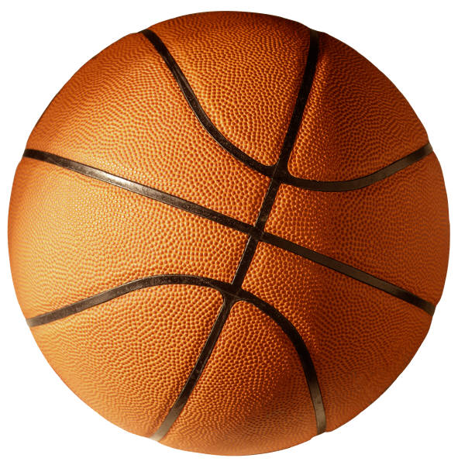

C:\Program Files\Microsoft Office\MEDIA\CAGCAT10\j0299763.wmf

