**8TH GRADE BOYS’ BASKETBALL**

Champions…LEXINGTON

Second Place…DALE

Third Place…SOUTH

Fourth Place...OXFORD

**7TH GRADE BOYS’ BASKETBALL**

Champions…LEXINGTON

Second Place…BROOKHURST

Third Place…ORANGEVIEW

Fourth Place…DALE

**8TH GRADE GIRLS’ SOCCER**

Champions…LEXINGTON

Second Place…SOUTH

Third Place…WALKER

Fourth Place…SYCAMORE

**7TH GRADE GIRLS’ SOCCER**

Champions…SOUTH

Second Place…LEXINGTON

Third Place…WALKER

Fourth Place…SYCAMORE

**GIRLS’ TENNIS**

Champions…OXFORD

Second Place…DALE

Third Place…LEXINGTON

Consolation…BALL



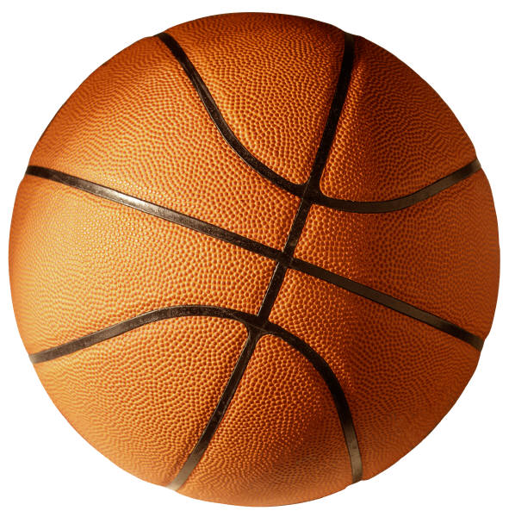

C:\Program Files\Microsoft Office\MEDIA\CAGCAT10\j0299763.wmf

