**8TH GRADE BOYS’ BASKETBALL**

Champions…LEXINGTON

Second Place…WALKER

Third Place…SOUTH

**7TH GRADE BOYS’ BASKETBALL**

Champions…LEXINGTON

Second Place…OXFORD

Third Place…WALKER

**8TH GRADE GIRLS’ SOCCER**

Champions…WALKER

Second Place…LEXINGTON

Third Place…SYCAMORE

**7TH GRADE GIRLS’ SOCCER**

Champions…LEXINGTON

Second Place…WALKER

Third Place…SOUTH

**GIRLS’ TENNIS**

Champions…OXFORD

Second Place…LEXINGTON

Third Place…BALL



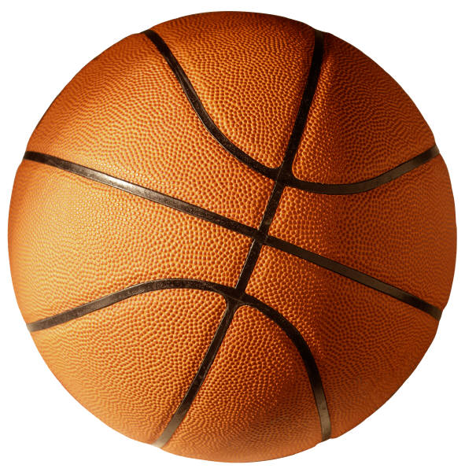

C:\Program Files\Microsoft Office\MEDIA\CAGCAT10\j0299763.wmf

