**8TH GRADE GIRLS BASKETBALL**

Champions…WALKER

Second Place…LEXINGTON

Third Place…BALL

**7TH GRADE GIRLS BASKETBALL**

Champions…LEXINGTON

Second Place…WALKER

Third Place…ORANGEVIEW

**8TH GRADE BOYS SOCCER**

Champions… SYCAMORE

Second Place…BROOKHURST

Third Place…SOUTH

**7TH GRADE BOYS SOCCER**

Champions… SOUTH

Second Place…SYCAMORE

Third Place…ORANGEVIEW





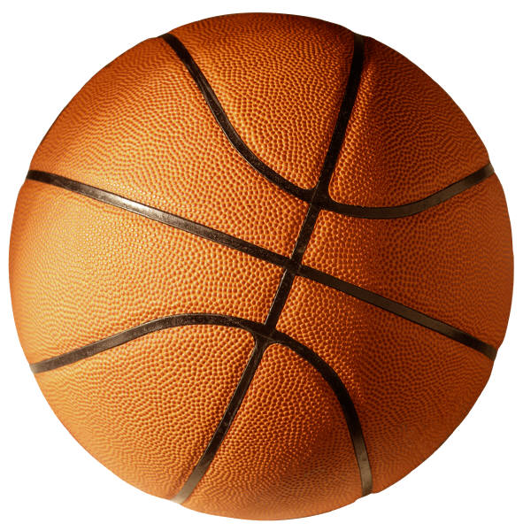

C:\Program Files\Microsoft Office\MEDIA\CAGCAT10\j0299763.wmf